CV for John Timms: 2016

 |  | PERSONAL
 |  |  |  |  | John Alan Timms  40 Pukeora Avenue  Remuera  AUCKLAND |  | Mobile +0064 21 580 159  Home +0064 9 522 2775
 |  |  |  |  |  |  | Email timmsfamily@xtra.co.nz
Married to Caroline for 27 years
Two children - Nicholas 23yrs and Jessica 21yrs
Health – excellent
Dual USA and NZ Citizenship – in New Zealand since 1989
Interests outside of work – golf, tennis

 |  | OBJECTIVE
My NZ wife and I made a lifestyle decision to have and bring up our family in NZ 27 years ago. We are committed to living in Auckland.

Ideally I am looking for another role that utilises my knowledge and experience to achieve great results whichever company I work for.
 |  | QUALIFIED BY
- MBA, Kellogg Graduate School of Management, Chicago, USA, June 1986. (Top 5 business school in USA), Honours List
- Bachelor of Arts Degree, Franklin and Marshall University, Lancaster, Pennsylvania, USA, May, 1983, Majors: Business/ French, Honours.
- 15+ years Divisional Management experience: 10 years as GM/CEO.
- 30+ years of senior Marketing and Sales experience
- Multinational business environment experience
- Experience in running a privately owned business
- 27 years FMCG, Pharmacy and Health industry experience in NZ
- Company Director of: BDM Grange, Brandlines and FNZ Brands
- Responsibility for securing NZ distribution rights for overseas brands
 |  | KEY STRENGTHS
- Consistently promoted in short timeframes
- A track record of achieving high sales and profit growth through a team-based approach; results oriented
- Personal Integrity
- Strategic and analytical thinking; an eye for detail
- Key team contribution is being a quick and original thinker who can take in and digest information quickly; ability to generate good ideas
- Ability to assemble/motivate teams to achieve sales/profit growth
- An ability to spot, attract and develop top talent
Summary of Positions
Duration |  |  | Company |  |  | Position |  | Reported To | Results |  |  |  | Results
Jan 2011 – March 2016 |  |  | Brink’s Poultry |  |  | Executive General Manager |  | Group MD (Owner) | Grew sales 50%/profits 250%
Dec 2008-Jan 2011 |  |  | FNZ/Brandlines |  |  | Chief Executive Officer |  | Group CEO in Australia | Set up new company.  35% sales/profit growth  in 1st year with Ferrero  established brands.
June 2006-Nov 2008 |  |  | API Consumer Brands |  |  | GM:Sales/Marketing |  | CEO in Australia | Huge Increase in Profits |  |  |  | Increased profits 40% to 8% of sales.
Dec 1998 - May 2006 |  |  | BDM Grange |  |  | Divisional General Manager |  | MD in NZ | 3 x sales, 10 x profit growth |  |  |  | Tripled sales. Profit up from -1% to 11%.
May 1993 - Nov 1998 |  |  | Healtheries |  |  | Sales and Marketing Manager |  | MD in NZ | doubled sales & profits |  |  |  | Doubled sales and profits.
 |  | John Timms  CAREER SUMMARY  Jan. 2011-  March 2016    June 2009-  Jan. 2011  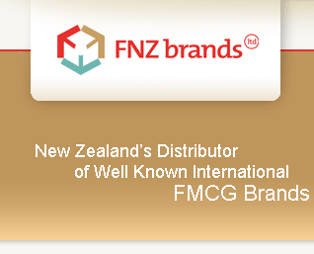       |  | Brink’s Poultry (Van Den Brink Poultry Limited): Auckland New Zealand  Manufacturer and marketer of Brink’s chicken products including fresh and frozen, whole chicken and portions, branded and unbranded and convenience value added products (meal solutions). The company grows, processes, sells and markets chicken products which are sold to: Supermarkets, Wholesalers, Food Service, Further Processors and Butchers. The Brink’s brand has 18% of the NZ chicken market behind Tegel and Ingham.  Executive General Manager (CEO)  - $170M+ in sales  - Full P&L Responsibility  - Management of 550+ staff  Results:  - Lifted sales 50%/profits 250% in first 5 years by implementing key initiatives  - Streamlined customer base to improve profitability  - Negotiated significant cost savings: $2m per year.  - Grew market share from 16 to 18% in highly competitive, commodity business  - Implemented merger of 2 separate manufacturing sites achieving cost savings  - Restructured Operations, Management and Sales team to deliver better results  - Formed New Product Development team: launched first ever NZ Organic chicken  - Formulated/implemented advertising and marketing plan to lift brand awareness while capitalising on complete rebranding project  - Upgraded 4 plants: Expanded capacity. Commissioned 5th new plant.  - Improved quality standards and overall product quality. Improved Health & Safety.  - Changed culture to positive, forward thinking one: increased engagement  Promoted from Brandlines to set up/run FNZ Brands Limited  FNZ Brands Limited: Auckland New Zealand (part of Brandlines Limited)  Distributor of Ferrero Rocher chocolates, Tic Tac, Nutella, Kinder Surprise, Bueno and Waterthins Crackers. The company provides full service representation for overseas brands owners including: sales to individual stores, head office key account presentations, trade promotion planning/execution, finance, general management, logistics. Customers include: Supermarkets, Route/Convenience, Oil and The Warehouse. FNZ now owned by DKSH.  Chief Executive Officer  - $25M in sales  - Full P&L Accountability  - Management of 16 full time staff plus 40 part time staff.  Results:  - Managed all aspects of setting up the company: found/set up office, hired staff, wrote and executed business plan, etc.  - Launched successful new agency brand: Waterthins Crackers, Berio Olive Oil  - Grew sales and profits 35% in 1st full year (previous distributor achieved flat results for prior 3 years).  - Exceeded 1st year profit budget by 50% through profitable sales growth and sound expense control (including trade spend).  - Grew overall business market share by 25% on prior year.  - Substantially grew distribution for established Ferrero brands.
 |  | December 2008-  May 2009          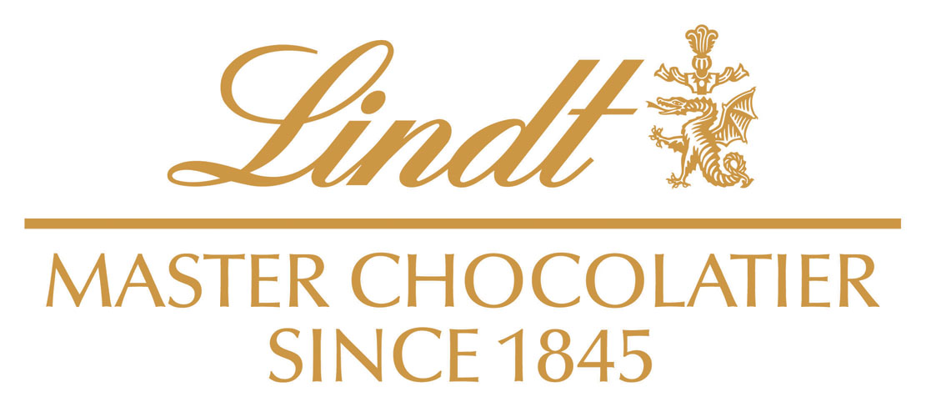 |  | Brandlines Limited: Auckland, New Zealand  Importer, distributor and marketer of a select range of international grocery and confectionery brands in New Zealand. The company provides sales, marketing, logistics and finance for brands sold to both Supermarkets and the impulse/convenience channels in New Zealand. The Company is New Zealand’s largest FMCG distribution company and is part of a group of 4 companies under the Rosella Foods Group name owned by Crescent Capital, an Australasian private equity company (Brandlines now owned by DKSH)  Chief Executive Officer  • $75M in sales  • Full P&L accountability  • Responsible for 160 staff  • Company Director  Brands include: Chupa Chups, Lindt Chocolate, Mentos, Sakata Rice Crackers, Smint, Werther’s Original and Asian Home Gourmet.  Customers include: All Supermarkets, Route trade, Oil, The Warehouse.  Results:  - Accelerated sales and profit growth: exceeded EBITDA target  - Implemented strategic planning process  - Started up new company (FNZ Brands) with over $25m in sales  - Promoted to the role of CEO of FNZ Brands Limited in June 2009.
 | John Timms
 |  | June 2006 –  November 2008       |  |  | API CONSUMER BRANDS  Auckland, NZ  Multinational distributor of top Australasian consumer brands. The company provides the sales, marketing, logistics and finance for brands sold to Supermarkets, Pharmacies and Health Food Stores. Business is mainly in NZ but also involves sales to Australia.  General Manager: Sales & Marketing  - $34M in sales  - Full P&L accountability  - Chair of Management Committee  - Member of Australasian Strategic Forum (top 25 Executives in the API group of Companies): $3B AUD group of companies.  - Responsible for 25 full time staff plus 40 part time merchandisers  Results:  - Grew profit from a loss to over $1.3M.  - Increased sales 4% on prior year in both of 1st two years (after 4 previous years of flat/declining sales)  - Grew Blackmores agency brand vitamin sales 30% on prior year, increased market share and lifted brand ranking from number 4 to number 2 in the NZ market. Successfully negotiated renewal of distribution agreement  - Repackaged/reformulated/relaunched the market-leading Health Basics brand for the first time in 6 years  - Grew the Pharmac pharmaceutical business 30%  - Attracted many new agency distribution brands: Voltaren pain relief, Slimmm weight loss, EAS body shaping. Retained/grew existing agency brands: Cool Charm body sprays.  - Restructured Sales and Marketing team: fewer people/better results  - Developed/launched new brands: DermaOil to compete with Bio Oil and Kiwifruit Scrubs to compete with St Ives Apricot Scrubs  - Grew Export Business Considerably through NPD and new markets  - Promoted from Sales and Marketing Manager after 2 months.
  CAREER SUMMARY

CAREER SUMMARY
Dec 1998 – May 2006           | BDM GRANGE LTD  Auckland, NZ  Multinational distributor of recognised international health and beauty brands. Company provides the sales, marketing and distribution to retail channels, including supermarkets, pharmacies, department stores and mass markets. Number two health and beauty company in New Zealand.  Divisional General Manager - Oct 2001 – Jan 2005  Group Marketing Director - Jan 2005 – May 2006  - $16M Divisional sales/$37M in Group sales  - Full P&L accountability  - Member of Senior Management Committee  - Company Director  - New Zealand Employee of the Year in 2003  - Responsible for 10 sales staff/9 x marketing staff  - Responsible for 40 x brands/15 x brand principals  Brand Management includes:  - V05 Haircare, Andrew Collinge Haircare, St Ives Skincare, Hawaiian Tropic Sunscreens and Sally Hansen Nail Products  Customers:  - Supermarkets, The Warehouse, Kmart – direct management  - Pharmacies, Department stores – via Sales Manager  Objective: maximise sales, profit and market share for all brands while improving brand image, consumer brand recognition, etc
Results:
- Tripled sales from 1998 to 2004. Promoted in January 2005
- Doubled market share in most categories in 6 years
- Increased pre-tax profit from -1% in 1998 to 10.8% in 2003
- Sourced and launched three new overseas brands
- Negotiated & signed distribution agreements for all major principals
- Negotiated much improved advertising rates
- Achieved highest worldwide market shares with all haircare and skincare brands: VO5 Haircare, St Ives Skin, Hawaiian Tropic
- Achieved the highest worldwide market share with the launch of TRESemme Hair Care in 2005/2006
- Promoted to role of Group Marketing Director Jan.2005

John Timms

Dec 1998 – Sept 2001 | Group Sales & Marketing Manager  Objective: maximise sales, market share and profit  Results: exceeded sales, market share and profit objectives in all years. Promoted to role of Divisional General Manager in Oct 2001.  Sales Responsibilities:  - Managing 8 x Sales Reps, 30 x Merchandisers, 2 x Brand Managers, 1 x Key Account Manager, 2 x Sales Managers, and 1 x Assistant  - Achieving sales targets, coordinating/negotiating deals and promotions  - Training and motivating sales representatives and other staff  - Preparing and presenting new product presentations and business reviews  - Organising and directing quarterly sales meetings  - Managing trade and overhead budget  Marketing Responsibilities: include maximising sales, market share and profit by  - Managing 1 x Brand Manager  - Developing the Annual Budget Business Plans  - Managing optimal spend of Advertising Promotion and Overhead Budgets  - Managing Stock Levels and Pricing  - Planning and Executing Strategies for new Product Launches  - Analysing and Presenting Marketing and Internal Data  - Planning and Executing Consumer Promotions and Advertising  Other Responsibilities: include management of supply chain for 1 year: introduced the standard and tracking mechanism to ensure that all orders are shipped the same day they are received.

John Timms

May 1993 – Nov 1998    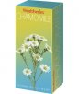 | HEALTHERIES OF NEW ZEALAND LTD  Auckland, NZ  New Zealand’s largest and most successful manufacturer and marketers of Vitamin Supplements, Natural Foods and Cosmetics  National Sales and Marketing Manager  - $25M in sales  - Member of Senior Management Committee  - Promoted to this role from Marketing Manager role in Feb 1997
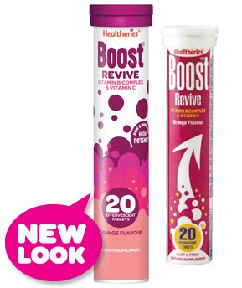  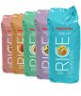 | Position Objective: to maximise sales, market share and profit  Results Achieved:  - Doubled sales and profits in 5 years  - Achieved top 5 Brand Awareness of all New Zealand brands in all categories  - Launched 15%+ to sales in new products each year  - Up skilled sales force – 1 x Representative won the David Forman national competition  - Developed 7 x TV advertisements and many radio/magazine campaigns.  - Directed research study that lead to successful brand repositioning  Sales Responsibilities:  - Managing 9 x Sales Reps, 1 x Key Account Manager and 2 x Customer Service staff  - Achieving monthly sales targets  - Sales representative coaching/training  - Organising/running bi-monthly sales meetings  - Presenting key account business reviews/new products presentations  - Planning/negotiating promotional activity plan with supermarket groups
Mar 1989 – Apr 1993   | GRIFFINS , Auckland, NZ  Senior Product Manager  Brands included: all ETA brand snack food products  - Responsible for all snack products ($70M in sales)  - Promoted from Product Manager role after 2 years.
Aug 1987 – Feb 1989 | ABBOTT LABORATORIES  North Chicago, Illinois, USA  - Market Research Analyst
Aug 1986 – Jul 1987 | - Medical Sales Representative:  Promoted to Market Research Analyst after 1 year.

John Timms

REFEREES
Karl Van Den Brink  Fred Hugues  Beverley Peacock  Warren Cummins | Employer/Position when working with John Timms  Van Den Brink Poultry  Van Den Brink Poultry  Van Den Brink Poultry  Dale Carnegie New Zealand | Current Position and Contact Numbers  Owner  Mobile: 027 492 5264  Karl@vandenbrinkgroup.co.nz  National Sales & Marketing Manager  Mobile: 027 471 7768  Fred.hugues@brinks.co.nz  National QA, H&S and Development Manager  Mobile: 027 837 5851  Beverley.peacock@brinks.co.nz  Managing Director  Mobile: 021 764 640  warren@dalecarnegie.co.nz
Chris Parker | Previous Managing Director  BDM Grange Ltd  (Nov 1998 – Jan 2005) | Mobile: 021 628 514  parkerpaget@clear.net.nz
Anthony Aitken | Griffins Foods Limited  General Manager Marketing  (March 1989 – April 1993) | Mobile: 027 504 8487

John Timms

AREAS OF STRENGTH
General Management | Marketing Management | Sales Management | Logistics/Manufacturing
MBA from top USA school which specialised in Marketing.  Company Director at BDM Grange, Brandlines and FNZ Brands.  MD/GM – 20 years P& L responsibility  22 years of Senior Sales, Marketing & Management experience  Cost control/margin improvement  Sales, profit and market share growth  Big picture/ideas person who can make it happen.  Good strategic visionary skills. Challenges current thinking.  Excellent people manager  Strong leadership abilities; trusted and respected by staff.  Delegation - gives clear direction & accountabilities to others  Consistent in treatment of others – firm, fair & compassionate.  Team-based approach  Performance management / performance appraisal process.  Good judge of talent  Excellent written and verbal communication/presentation skills. | 27 years successful Marketing experience in NZ.  Excellent strategic Marketer/Sales Mgr.  Consumer oriented: focus on what the consumer is thinking and how to positively influence this for my brand in the most cost effective manner.  Track record of measurable significant improvement in brand awareness.  Demonstrated capability to be flexible in having worked in different company cultures with very different brands and having achieved success with all of them: Brink’s, FNZ (Ferrero Rocher), Brandlines (Sakata, Lindt), API (Blackmores, Health Basics), Healtheries, Griffins (ETA Snacks), BDM Grange (VO5, TRESemme, Bio Oil world wide record market shares).  Hugely successful in identifying potential new products, sourcing them from overseas and/or developing them domestically.  Very knowledgeable in media strategy/placement, negotiating media cost savings, PR, consumer promos. | Sales and Marketing Management experience  Achieved top sales and profit results in varied categories, companies, channels over 25 year period in NZ.  Successful sales person in USA & NZ.  Significant experience in delivering top results with customers at Head Office level: customer-focused mentality.  Successfully motivated, directed sales teams to achieve top results over past 21 years at Healtheries, BDM, API, Brink’s  Add value through careful recruitment combined with constant training as to how to sell effectively while targeting, measuring, managing, rewarding staff.  Sales and territory analysis; able to reorganise/restructure territories for maximum effectiveness.  Good at identifying opportunities and demonstrating leadership and planning ability to maximise these.  Constant focus on cost control/reduction  Negotiation of trading terms & discount structures at senior level  Manage and control sales costs | Managed Supply Chain at BDM for 1 year: increased on-time/in full delivery percentage from 80% to 98%.  BDM Grange: Conducted full review of freight costs/suppliers resulting in a change of freight company, savings and improved results.  Negotiated cost savings consistently for over 21 years.  Considerable exposure to manufacturing at API, Healtheries & Griffins.  Griffins: Studied capabilities of new piece of machinery and developed/launched a successful new product line that delivered a good return on investment.  Griffins: Oversaw project that compared cost of setting up new manufacturing line versus outsourcing and secured contract manufacturer.  Healtheries: generated raw material savings with purchasing department. Involved with manufacturing to generate increased efficiencies through more common raw materials, thus enabling better purchase prices, less manufacturing changeover time, reduced labour costs etc.
The Coalface Study is an annual independent survey of all Supermarkets where every supplier is rated by the Supermarkets on service, ability to grow their business, etc. In 2006, before I joined API, you can see that its brands, Health Basics and Blackmores ranked so low that they didn’t make the top half, whereas in 2007 this improved and in 2008 they were ranked number 1 and 2 in one Supermarket group out of 42 non-food suppliers that were ranked. All other Supermarket groups have shown considerable improvement too.

